**MIT xPRO Data Engineering Certificate**

**Dask, Feather, Parquet**

Feather and Parquet are formats that can be used to handle very large volumes of data. DASK is a Python library used to handle big data, which takes advantage of how modern computers are set up with multiple cores to run processes in parallel.

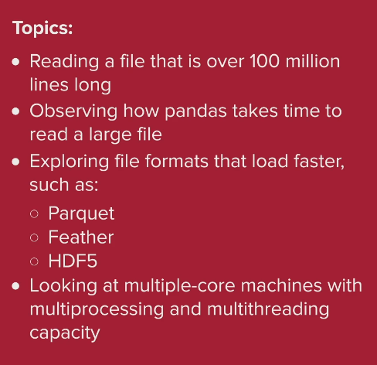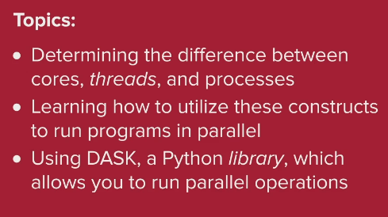

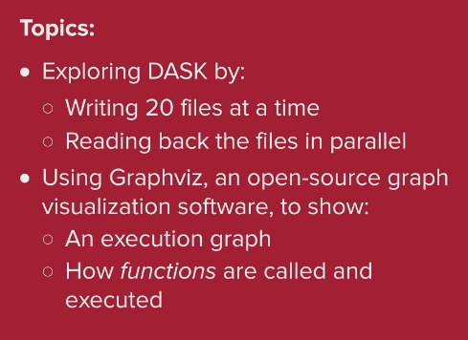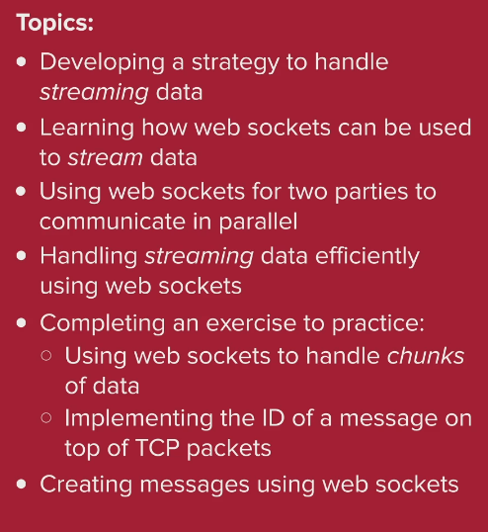

How to read a large CSV file in Python to a pandas dataframe, and output the file using the Parquet and Feather formats:

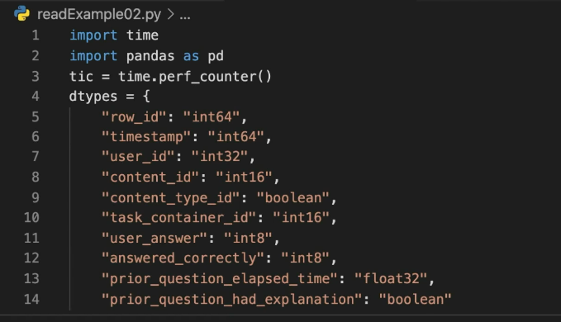

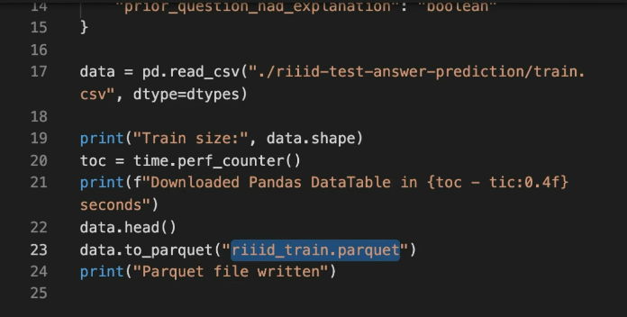

DASK is a parallel computing Python library. You can use the DASK library to create, read, write, and analyse multiple files in parallel, and you can simulate parallel processing across distributed machines using DASK.

The architecture of computers with multiple cores allows programs to run in multiple threads. Threads allow sections of a program to be executed at the same time, in parallel, with different priorities.

In this example, the increments functions are run in parallel, whilst add must be run sequentially:

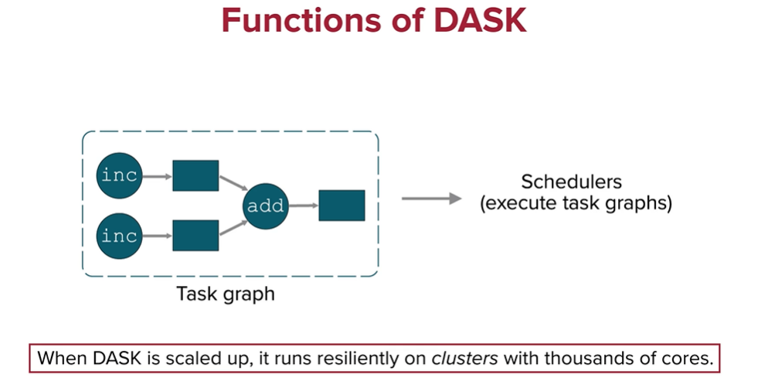

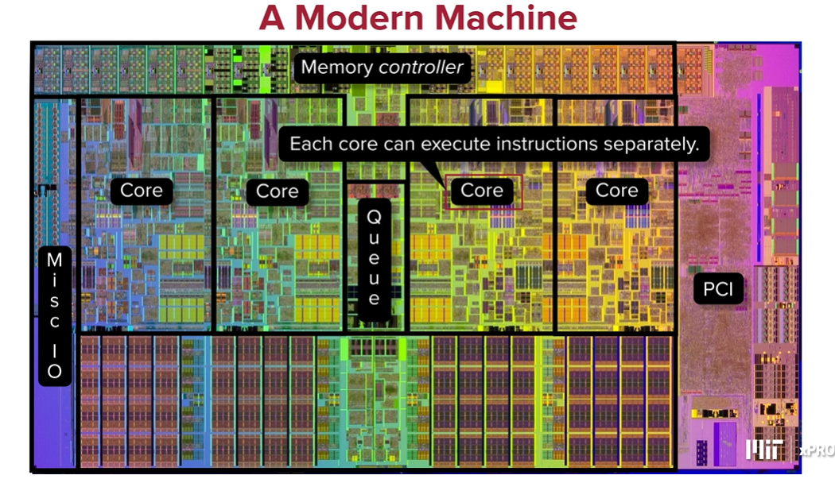

A clock cycle (or clock tick) is the smallest unit of time in a CPU, determined by the CPU clock's frequency. For example, a 3 GHz CPU has a clock cycle of 1/3,000,000,000 of a second. When referring to cache, clock ticks usually indicate the number of cycles the CPU needs to access data from the cache. If data is in the cache (a cache hit), accessing it will take fewer clock cycles compared to accessing data from the main memory (a cache miss).

The cores have access to different levels of cache. Modern CPUs have multiple levels of cache:

* L1 Cache: Fastest and closest to the CPU cores, usually takes 1-3 clock cycles to access.
* L2 Cache: Larger but slower than L1, typically takes 10-20 clock cycles.
* L3 Cache: Even larger and slower, but shared across CPU cores, usually takes around 30-50 clock cycles.

Cache memory is located on the CPU chip (L1 and L2) or on a separate chip close to the CPU (L3). RAM is the main memory and is located on the motherboard separate to the CPU. RAM is much larger than cache, but cache is much faster to access and more expensive.

When a CPU needs data, it first checks the cache. If the data is not there (a cache miss), it then checks the RAM. If the data is not in RAM either, it will retrieve it from the storage device (e.g., SSD or HDD), which is much slower. By keeping frequently accessed data in the cache, the system can operate much more efficiently.

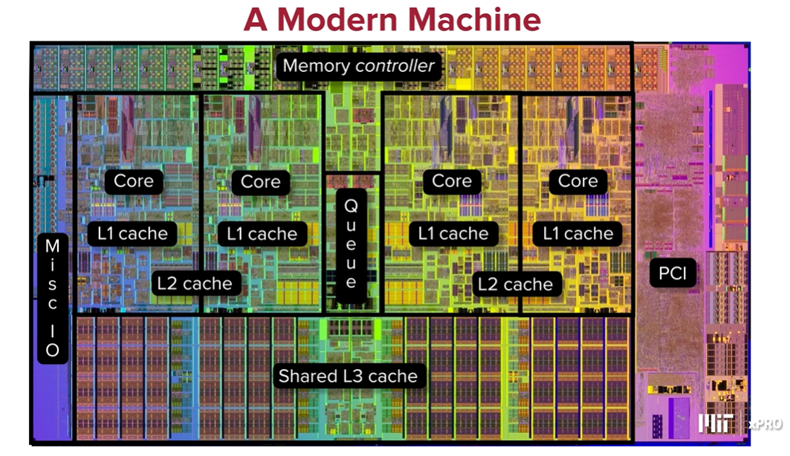

Threads:

* A core operates on a set of instructions from threads.
* A core can swap threads in and out over time.

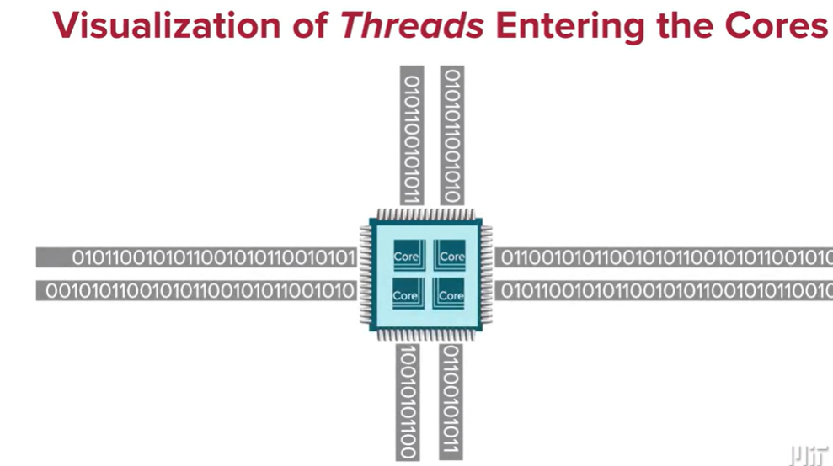

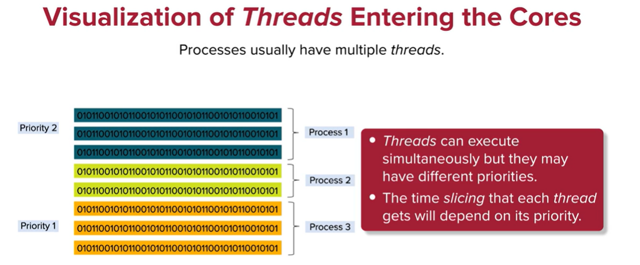

Note: Time slicing is a technique used in multitasking operating systems to ensure that multiple threads (or processes) get a fair share of the CPU's time. The goal of time slicing is to allow each thread to run for a small, fixed amount of time (a "time slice" or "quantum") before the CPU switches to another thread. This helps achieve concurrent execution of threads, even if there are more threads than CPU cores available.

You scatter tasks across multiple threads and then gather the results, with the possibility that the threads complete their tasks and return results at different times or in a different order than they were dispatched. This concept is common in parallel and distributed computing to improve performance and efficiency.

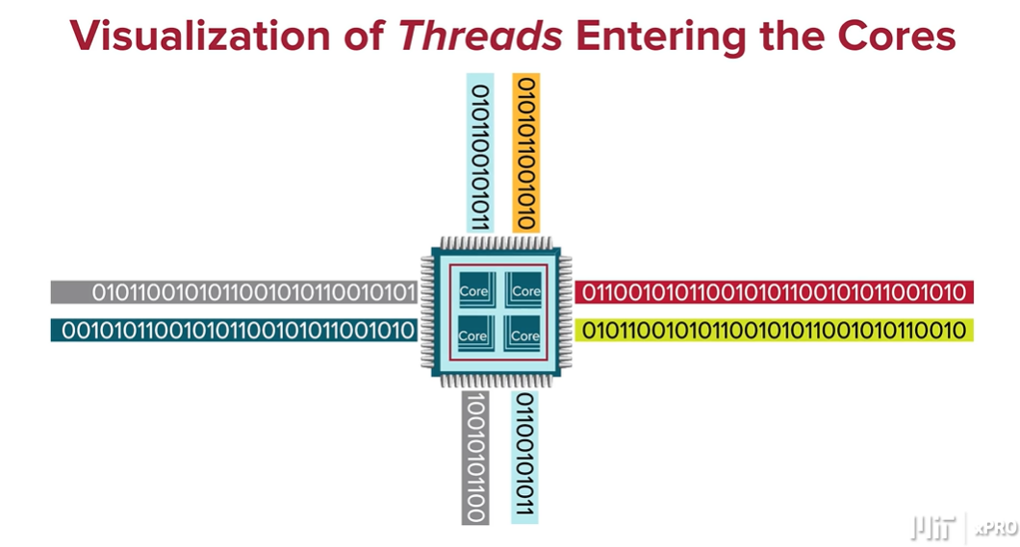

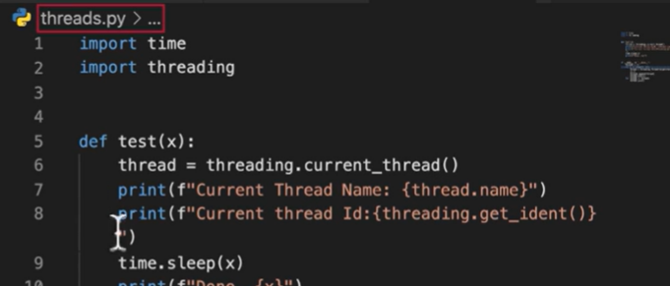

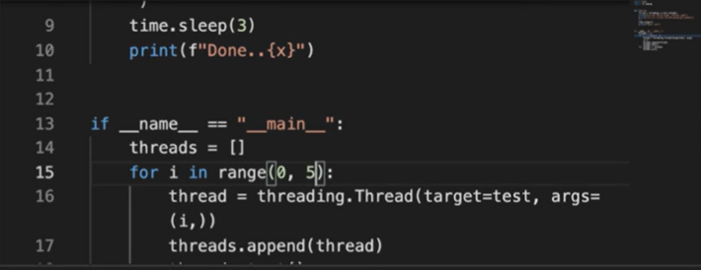

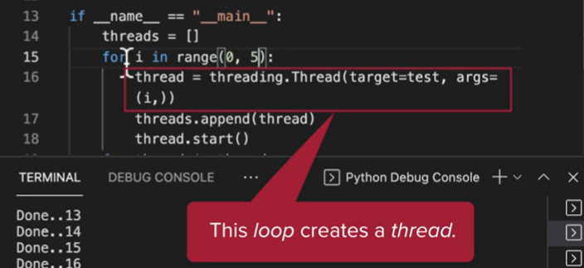

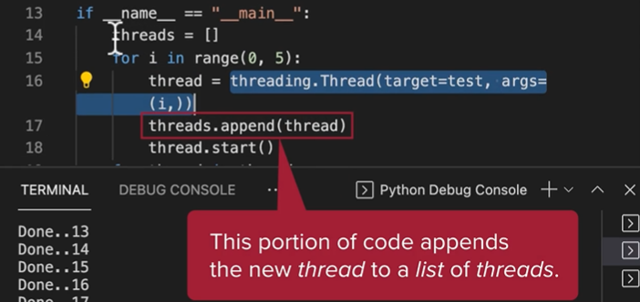

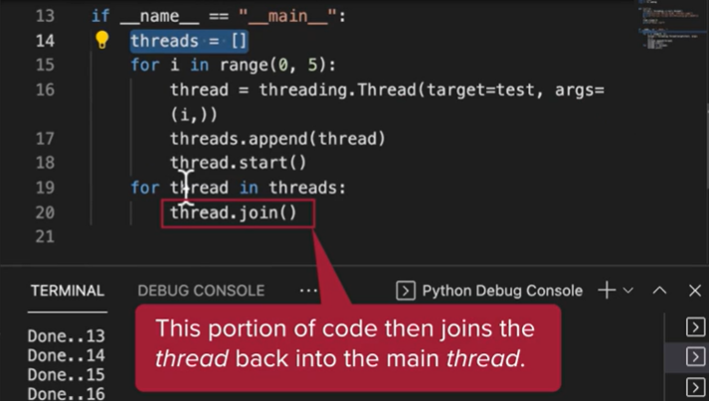

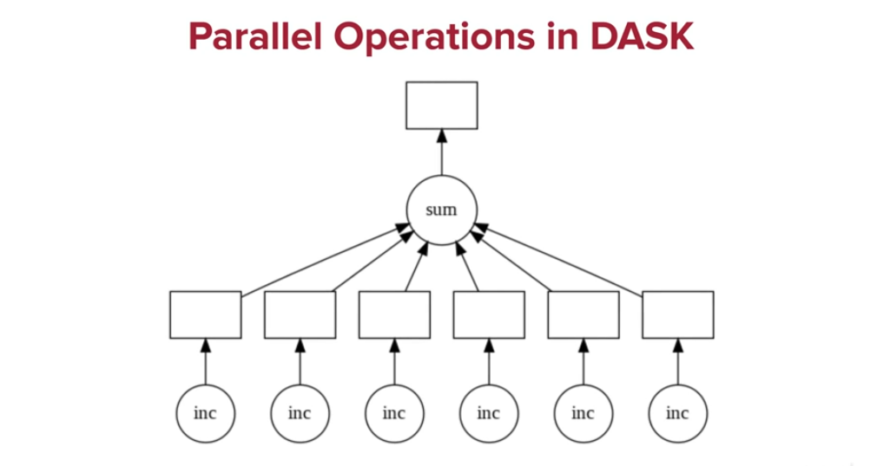

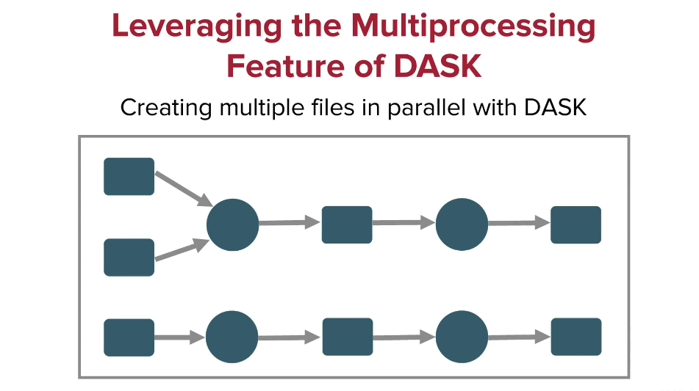

You can use DASK to create 30 files in parallel. This program creates synthetic time series data and places them each in a csv file. Each file has thousands of lines with one line for each second of a day and each day in a file. The column headers are: timestamp,name,id,x,y:

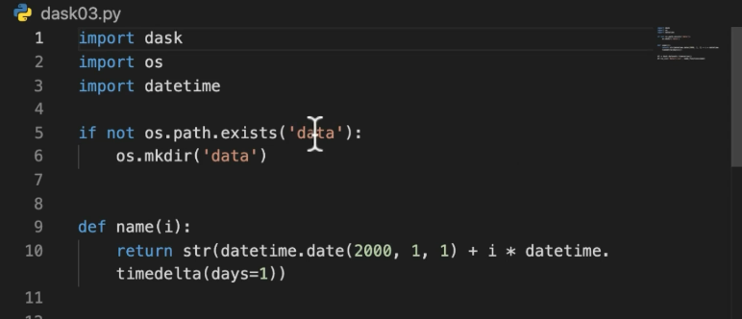

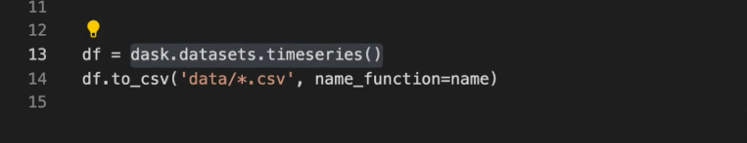

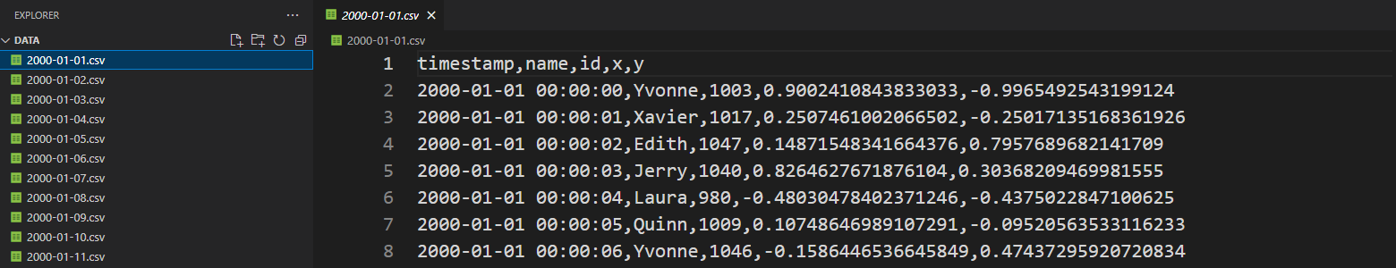

This program reads the files in parallel. It creates a single dask dataframe out of several pandas dataframes (ie those stored in the 1-30 csv files:

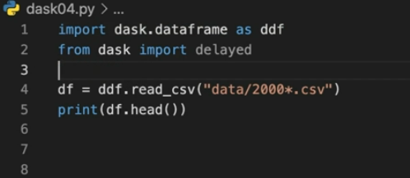

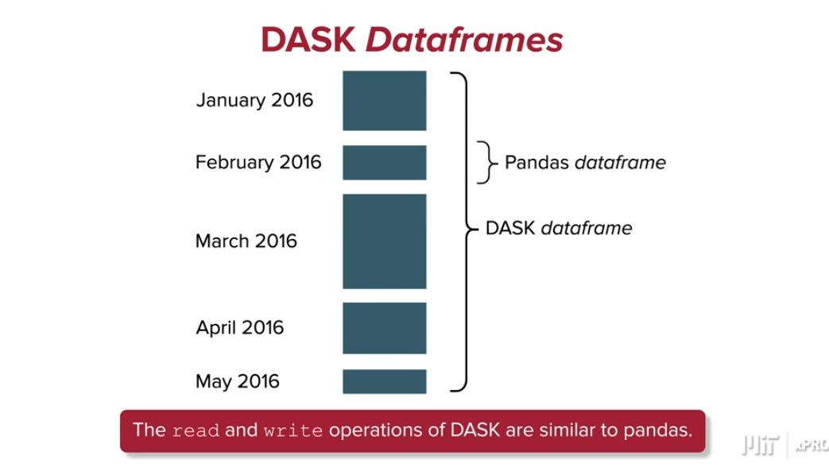

This program calculates the mean of the x column in all of the lines of the dask dataframe. The compute() function spreads the computation workload in a parallel fashion:

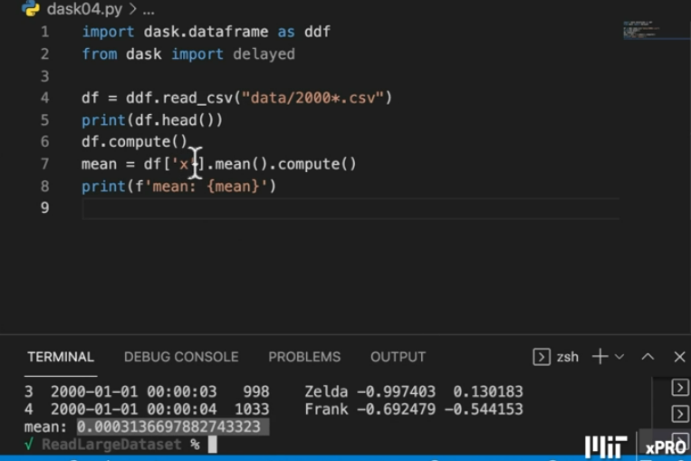

This program also calculates the number of columns and rows in the dask dataframe:

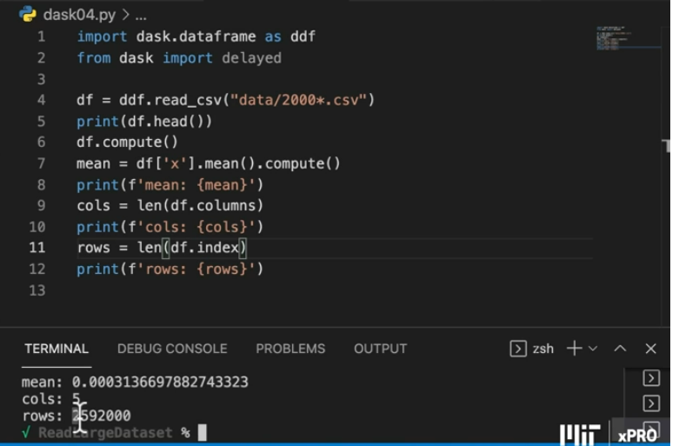

DASK allows you to distribute computations and other tasks across different machines. This simulates the process using different windows. First launch the dask-scheduler. Then create 2 workers that connect to the same scheduler:

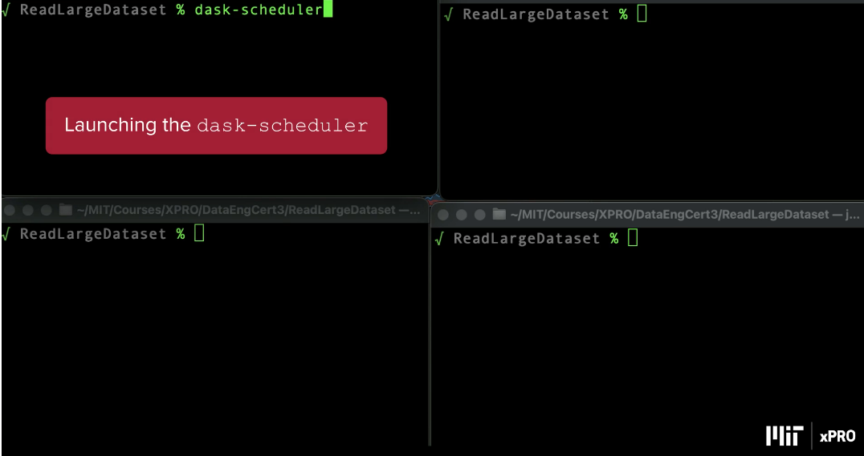

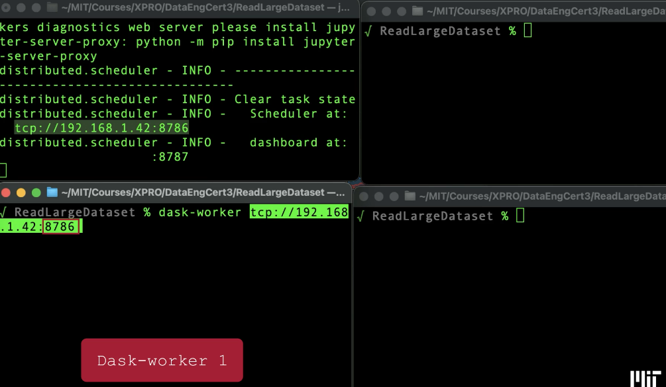

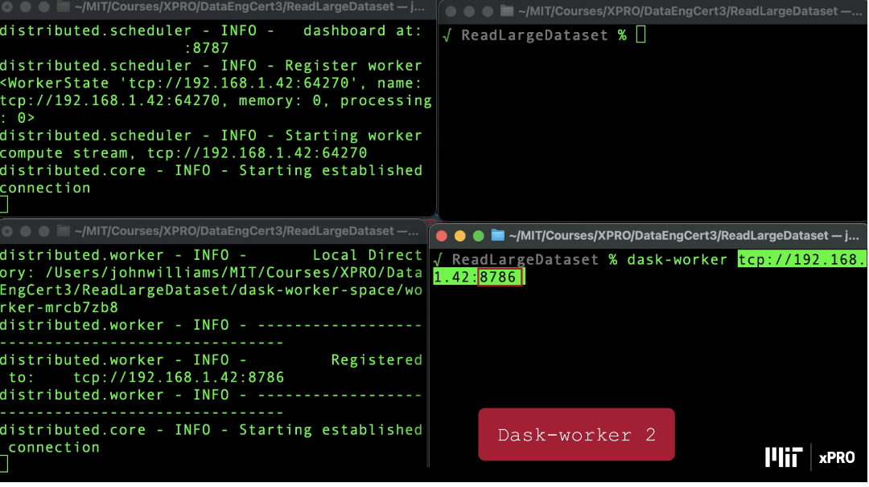

Then create a client using python:

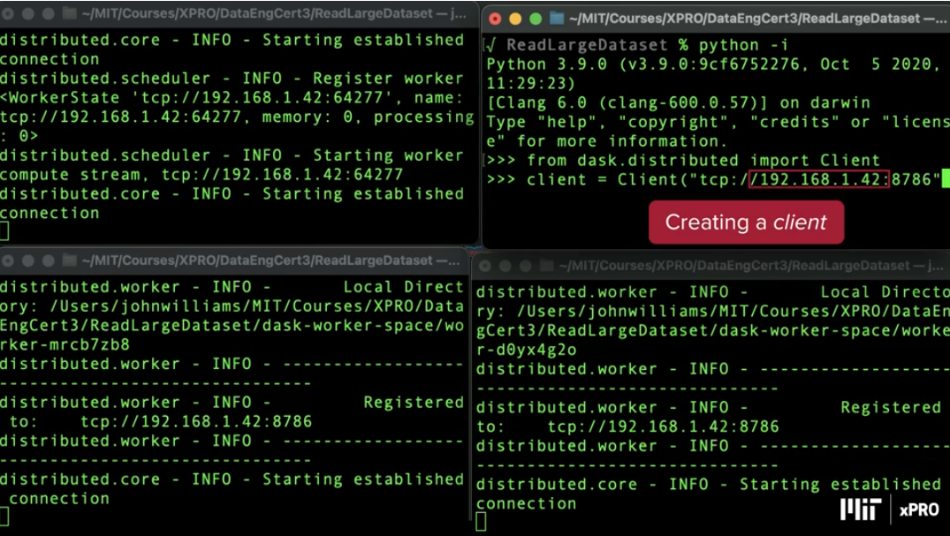

And then use python to write a program:

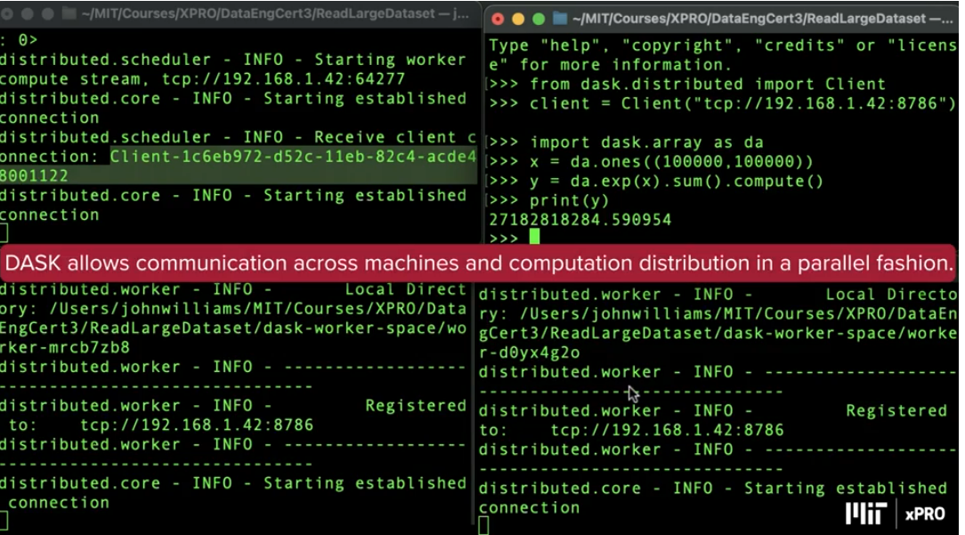

Crtl + C to take down the scheduler, which logs out each of the windows.

**Parquet**

Reading and writing large data files using the pandas *library* can be time consuming, and it can use a large *chunk* of your computer’s memory.

To overcome these issues, the Apache Software Foundation created Parquet, an open-source columnar storage format, for use in big data analysis. The main difference between traditional storage and the type of storage offered by the Parquet format resides in the way that data is processed and stored. Parquet stores data by column, thus the term columnar storage format, rather than by row. This offers far more efficient access to data because having the data stored in columns keeps the data of the same type together, thus reducing the *querying* time.

For example, traditional databases are row-oriented databases that store data by row. In these databases, the fields for each record are stored in a long row — for example, “Customer 1: name, address, date of birth, etc.” In a columnar database, the names of every customer appear in a “name” column and all the addresses appear in an “address” column, etc.

**Reading and Writing Files Using the Parquet Format**

Before you start reading and writing files using the Parquet format, you must install theApache Arrow *library*, which is used by pandas to process Parquet files.

To install the Apache Arrow *library*, run the following command in a Terminal window:

pip install pyarrow

Suppose that you have a *dataframe* titled df that is defined by the syntax below:

import pandas as pd  
df = pd.DataFrame(data={'col1': [1, 2], 'col2': [3, 4]})

You can write the df *dataframe* in the Parquet format by using theto_parquet()*function*. This *function* takes, as an *argument*, the name of the file where you want to save your data, with the .parquet extension, as shown in the command below:

df.to_parquet('df.parquet')

Running the commands above in a Jupyter Notebook will create a df.parquet file in the same *directory* as your Jupyter Notebook. The df.parquet file contains your *dataframe* written in the Parquet format.

You can verify that the df.parquet file has been created by running the ls command in your Terminal window.

You can also read files from a Parquet formatted *dataframe* by using the read_parquet()*function*. This *function* takes, as an *argument*, the name of the file that you want to read with the .parquet extension using the command below:

pd.read_parquet('df.parquet')

By running the above command in a Jupyter Notebook, you will be able to see your original *dataframe*,as illustrated in the image below:

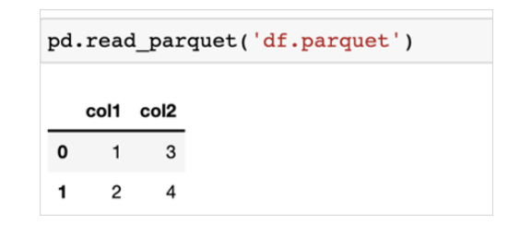

Now that you have a basic understanding of how the Parquet format works, you are ready to start reading and writing files with Parquet.

**Feather**

The Apache Software Foundation offers another type of open-source columnar storage format called Feather.

The main differences between the Parquet and Feather formats can be summarized as follows:

**Parquet vs. Feather Format**

| **Parquet Format** | **Feather Format** |
| --- | --- |
| The Parquet format is designed for long-term storage. | The Feather format is better suited to short-term storage. |
| The Parquet format is more expensive to write in terms of memory than the Feather format, as it features more layers of encoding and compression. | Using the Feather format enables faster input/output speeds and uses less memory. |
| The Parquet format is a standard storage format for analytics that is supported by many different systems: Spark, various AWS services, BigQuery, etc. So, if you are doing analytics, Parquet is a good option as a reference storage format for *querying* multiple systems. | In the Feather format, data is written using a binary format, which enables faster processing speeds. This reduces memory cost, but it is not ideal for long-term storage. |

**Reading and Writing Files Using the Feather Format**

Before you start reading and writing files using the Feather format, you must install the Apache Feather *library*, which is used by pandas to process Feather files.

To install the Feather *library*, run the following command in a Terminal window:

pip install feather

Suppose that you have a *dataframe* titled df that is defined by the syntax below:

import pandas as pd  
df = pd.DataFrame(data={'col1': [‘a’, ‘b’], 'col2': [‘c’, ‘d’]})

You can write the df *dataframe* in the Feather format by using theto_feather()*function*. This *function* takes, as an *argument*, the name of the file where you want to save your data, with the .ftr extension, as shown in the command below:

df.to_feather('df.ftr')

Running the above command in a Jupyter Notebook will create a df.ftr file in the same *directory* as your Jupyter Notebook. This file will have the df *dataframe* written in the Feather format.

You can verify that the df.ftr file exists by running the ls command in your Terminal window.

You can also read files from a Feather formatted *dataframe* by using the read_feather()*function*. This *function* takes, as an *argument*, the name of the file you want to read, with the .ftr extension, as shown below:

pd.read_feather('df.ftr')

By running the above command in a Jupyter Notebook, you should be able to see the original df *dataframe*:

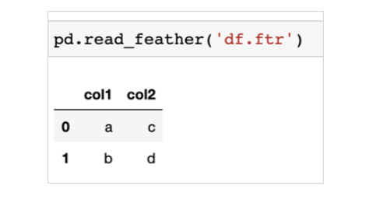

Now that you have a basic understanding of how the Feather format works, you are ready to start reading and writing files using it.

**Key Concepts of Parallel Computing**

To understand the advantages of parallel computing, first it is necessary to understand the concept of traditional computing in series, also known as sequential computing. When traditional computers were first introduced, a compiler would accept a set of instructions, such as those included in a written programming file. The compiler would then transform these human-written instructions into a set of machine-language instructions. After that, the set of instructions would be fed through the central processing unit (CPU) to be executed sequentially in a specific series.

**Sequential vs. Parallel Computing**

When the CPU processes each execution, there are a set of processes that must be completed in a specific order. Simply put, the CPU must begin by fetching the instructions, then decoding the instructions, executing the instructions, reading from memory, and finally, writing the results to memory. The order of these processes for sequential computing is depicted in the following image:

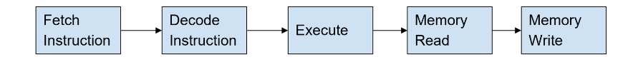

The concept of parallel computing can be understood by first learning parallel processing. Parallel processing works by breaking up a large set of instructions into smaller, independent sets. Then, multiple CPUs are used to each handle a smaller set of instructions simultaneously. These different CPUs are interconnected by a shared memory bus, so that when it comes time to read and write to memory, each CPU is accessing the same physical memory addresses, which are known as *registers*.

The image below shows how a large set of instructions is first divided into different *tasks*. Each *task* is then performed sequentially by each of the *processors*:

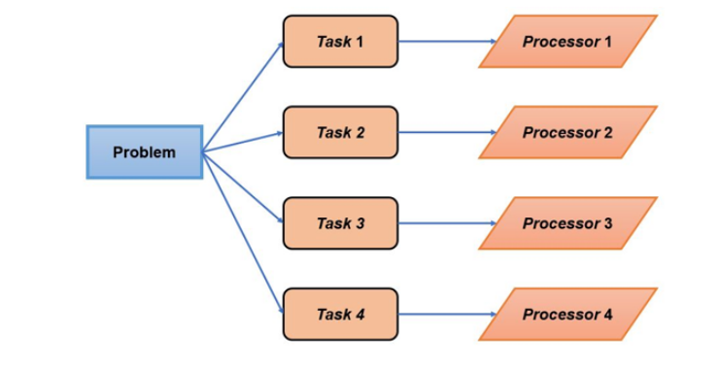

**Parallel Processing**

The goal of parallel processing is to transform a traditionally slow computing process into a faster, more energy-efficient process by using more CPUs. Today, devices advertise their multi-*core* CPUs with even smaller mobile devices, such as the iPhone 13, which contains six different *cores*, each designed to handle a specific set of instructions. It is also common for the graphic processing unit (GPU) to work alongside the CPU to handle more computationally intensive instructions when needed.

*Thread* is a term used in parallel programming to describe a single CPU pipeline that is responsible for processing a specific, smaller *task* in order to solve a larger problem.

Now that you understand parallel processing, you can examine the differences between parallel processing and parallel computing. Parallel processing is the technique of breaking up large problems into smaller *tasks*, which will then be fed into different CPUs. Parallel computing is the software that controls how this method is implemented. Both parallel processing and parallel computing must happen in tandem, as your software must agree with what the hardware is doing. Even though parallel processing and parallel computing are often used interchangeably, it is important to note the distinction between these two terms.

**Implementing Parallel Computing**

There are four different levels of parallel computing that can be implemented. Each of the four levels is described below:

**Levels of Parallel Computing**

| **Bit Level** | The bit level increases the number of bits that the *processor* can consume in a single instruction (OmniSci 2021). This reduces the overall instruction set. |
| --- | --- |
| **Instruction Level** | At the instruction level, hardware can decide which instructions to run in parallel or which software approach to use in situations that the compiler decides (OmniSci 2021). |
| ***Task* Level** | At the *task* level, multiple *processors* run smaller *tasks* at the same time (OmniSci 2021). |
| **SuperWord Level** | The SuperWord level consists of a vectorization technique to process in-line code in parallel (OmniSci 2021). |

**Potential Issues with Parallel Programming**

As you can imagine, problems may arise when executing multiple commands. For example, if a *thread* encounters an instruction that reads a variable from memory at the same time that another *thread* is attempting to write that same variable to memory, you will encounter a *race condition.* *Race conditions* are undesirable because they can change how your program acts and processes every time it is run. Sometimes *race conditions* can lead to a complete processing failure. If parallel computing is not configured correctly, this can occur in many ways. However, it happens most commonly when reading or writing to a file or variable.

**Techniques and Solutions for Parallel Computing**

*Libraries*, parallel programming models, and concurrent programming languages have been created to run parallel processing for applications as well as larger systems. Some techniques used by these implementations are as follows:

**Parallel Computing Techniques**

| **Checkpoints** | Checkpoints are used to store the current state of variables periodically, which can improve fault tolerance. If a program running in parallel ever enters a state that becomes stuck due to an unknown variable state, the *thread* can reference the last checkpoint instead of throwing a runtime exception. |
| --- | --- |
| **Automatic Parallelization** | Automatic parallelization is the technique of transforming sequential code into multi-*thread* code. This is usually performed by the compiler and is used on CPU *cores* with shared memory. |
| **Parallel Programming Languages** | Parallel programming languages leave multi-*threading* up to the individual programmer. There are two types of parallel programming languages, one which is performed on shared memory CPU *cores*, and another with distributed memory CPU *cores*. The latter type uses messages to communicate with each *thread* while shared memory CPUs manipulate shared memory variables (OmniSci 2021). |
| ***Locks* and Semaphores** | *Locks* and semaphores are a complex programming technique derived from a simple concept. When a *thread* seeks to perform a memory access, known as a resource consumption, the *thread* will place a *lock* on that resource so no other *threads* can have access during the execution. A semaphore is then used as a signaling mechanism, and a *thread* that is waiting for a semaphore can be signaled by another *thread*. |
| **Sleeping** | A *thread* can be put to sleep when not in use or waiting for a *lock* to be released. Putting the *thread* to sleep essentially stops the CPU from executing commands. Without sleeping, the *thread* will constantly be checking on the *lock* and using valuable CPU power. On mobile devices, this consumes a lot of battery, so it is desirable to sleep any *threads* that are not actively being used. |

**Dask**

DASK is a parallel computing *library* for Python. DASK enables programmers to have more control over the way that a program is compiled and run. In this mini-lesson you will learn the basics of DASK.

**Advantages of Using DASK**

DASK is useful for processing big data *collections*. DASK allows for large *arrays* and *dataframes* that normally wouldn’t fit in-memory to be processed in parallel. DASK is a preferred alternative to NumPy and pandas as these *libraries* cannot handle big data when the data is too large to fit in-memory (Dask Developers 2018).

DASK is a dynamic *task* scheduler. DASK allows the programmer to identify specific *tasks* to be computed in parallel. The execution engine can do so on big data *collections* or on user-defined workloads. The use of DASK can replace other *threading* and multi-*core* processing *libraries* as DASK works to use small amounts of memory and process *tasks* with low latency (Dask Developers 2018).

**Getting Started with DASK**

First, open a new Colab Notebook.

Next, run the following command in your Colab Notebook to download the DASK dependencies in Colab (Sowmya.L.R 2020):

pip install "dask[complete]"

Note: If the first version of the command does not work, try this version of the command:

%pip install "dask[complete]"

If both of the commands above are not running properly, you may need to uninstall and reinstall the gym *library* by running the commands below in a Terminal window:

pip uninstall gym

pip install gym

**Using DASK**

A major advantage of using DASK is that DASK allows for big data files to be read quickly.

Try loading a CSV file with DASK. Begin by downloading this [CSV dataset file](https://classroom.emeritus.org/courses/7145/files/1904192/download) to your local device.

Next, copy the following command into your Colab Notebook:

| from google.colab import files  uploaded = files.upload()  import dask.dataframe as dd  %time df = dd.read_csv("dataset.csv", encoding = 'ISO-8859-1') |
| --- |

After running the above command, you will be prompted to choose a file from your local device. Choose the previously downloaded CSV dataset file.

DASK also allows for *task* visualization. This can help users to understand how *tasks* are being processed, and it is also useful when debugging code. Run the code below to try out a sample visualization to see how useful the feature is:

| import dask.array as da  x = da.ones((50, 50), chunks=(5, 5))    y = x + x.T    y.visualize(filename='transpose.svg') |
| --- |

**Running *Tasks* in Parallel with DASK**

In addition to the ability to load and process large datasets, DASK also provides the ability to program specific independent *tasks* to run in parallel. This is helpful, as a *task* can be programmed and a specific *function* can be labeled as a *task*. To do so, annotate the *function* with @Delayed, which indicates to DASK that you wish for this *function* to be executed at a specific desired time. Try out this *function* with the following case study scenario:

Consider that you’re writing a piece of a program that needs to compute the following equation:

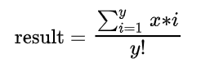

You decide that the most optimal way to compute this is to break up the problem into a numerator and denominator. The two variables are independent of each other because you can calculate one without knowing the result of the other. Therefore, you know the program will run more quickly if you can compute both the numerator and denominator at the same time and then simply divide the result.

Continue working on Google Colab on the same notebook you used before.

First, you will need to import the delayed *function* from DASK using the command below:

| from dask import delayed |
| --- |

Next, run the following code for the numerator and denominator:

Numerator:

| @delayed  def Numerator(x,y):  sum = 0  for i in range(1, y+1):  sum = sum + (i * x)  return sum |
| --- |

Denominator:

| @delayed  def Denominator(y):  factorial = 1  for i in range(y,1, -1):  factorial = i* factorial  return factorial |
| --- |

Then, divide the numerator by the denominator using the following command:

| def Divide(numerator, denominator):  return numerator / denominator |
| --- |

To calculate the whole result, execute the following instructions:

| numerator = delayed(Numerator)(1500,10)  denominator = delayed(Denominator)(10)  result = delayed(Divide)(numerator, denominator)  result.compute() |
| --- |

This process allows DASK to manage how the result is computed. If you execute the result.visualize()*function*, you can see exactly what DASK is doing in the background. The result.visualize()*function* is shown in the following image:

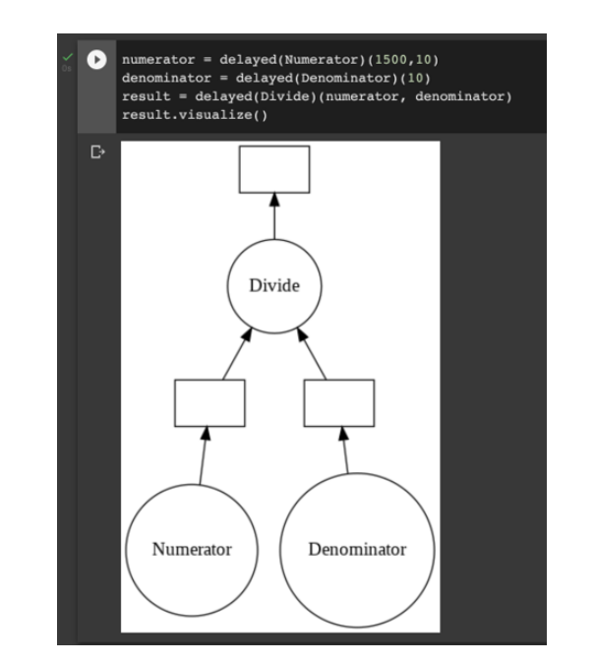

As expected, DASK handles the two *tasks* independently and then divides the result. Instead of waiting for your CPU to finish calculating the result of the numerator and then getting started on the denominator, DASK calculates both variables simultaneously to save valuable time. This is one of many powerful advantages of parallel computing. Try exploring some examples on your own to get more familiar with the software. As you practice using DASK more, it can be fun to challenge yourself and explore new ways to speed up an application.

**Parallel Processing Across Distributed Machines**

So far you have used DASK to run *threads* in parallel on your local machine. In this mini-lesson you will learn how to use DASK to run *threads* in parallel across different machines.

DASK is a centrally-managed distributed computing platform. The dask-scheduler is a process that manages all the DASK *tasks*, called dask-workers, that are assigned to it. To run the dask-scheduler, depending on the OS you are using, open the Anaconda Prompt or a Terminal window and enter the dask-scheduler command as shown below:

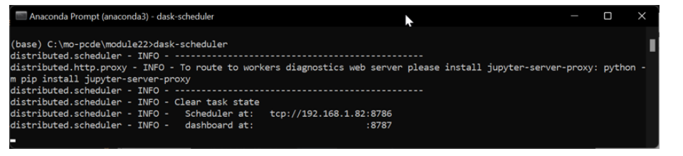

The default address for the dask-scheduler running on your local machine is: tcp://192.168.1.82:8786.

**Important Note:** The TCP address above may be different for you. Ensure that you are using the same address that your dask-scheduler is using throughout your code.

To create a dask-worker, depending on the OS you are using, open the Anaconda Prompt or a Terminal window and enter the following command: dask-worker <scheduler address>.

For this simulation, enter the following command to connect the dask-worker process to the dask-scheduler that you just created: dask-worker tcp://192.168.1.82:8786. See the command prompt image below:

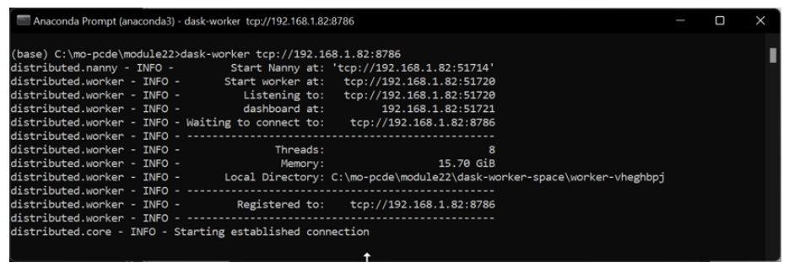

Note that for this simulation, the dask-scheduler is running on your local machine through the localhost, but you could also use DASK to run the dask-scheduler on another machine.

Notice that when the dask-worker was started, the dask-scheduler recognized the dask-worker, as shown in the image below:

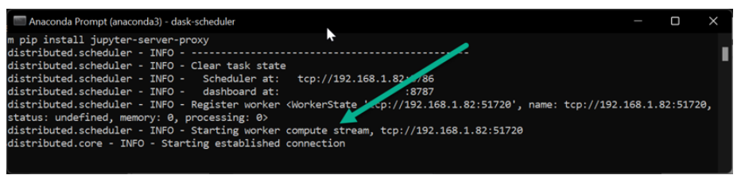

Depending on the OS you are using, open the Anaconda Prompt or a Terminal window and launch another dask-worker process. Now you should have three separate DASK processes running (one dask-scheduler and two dask-worker processes). The three separate processes are shown in the image below:

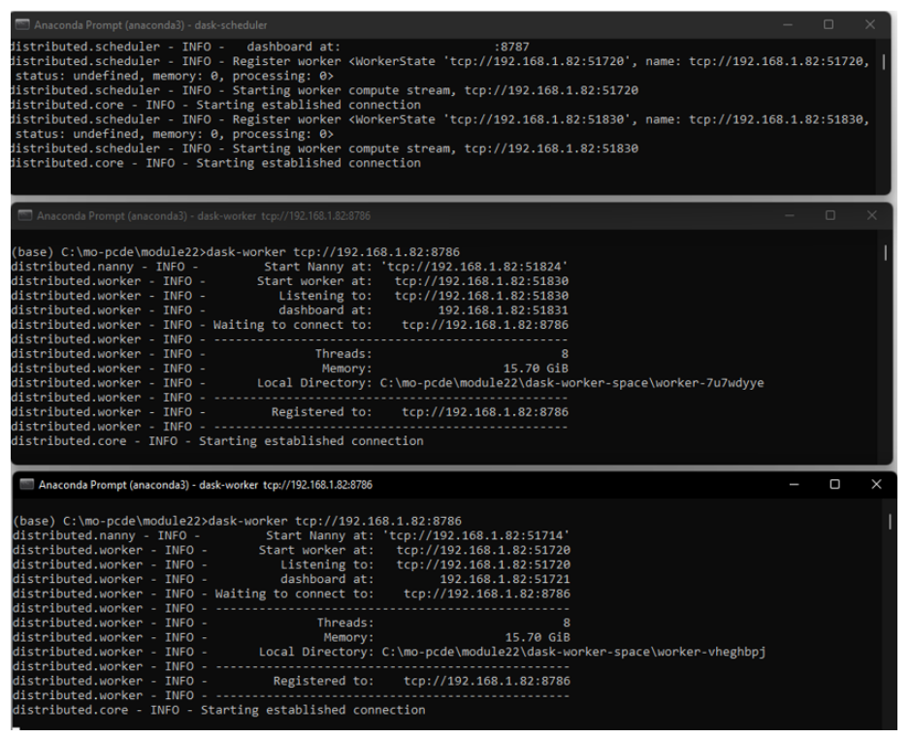

Remember that, for this simulation, all three DASK processes are running on your machine via different localhosts. However, the power of DASK parallel processing is that these processes could be set up to run across different machines.

Now you are ready to code and run the *client* to perform computations on the dask-scheduler. Open a Jupyter Notebook and run the following code:

| import dask.array as da  x = da.random.random((40000, 40000))  y = da.exp(x).sum()  from dask.distributed import Client  client = Client("tcp://192.168.1.82:8786")  y.compute() |
| --- |

Notice that the code above uses the same TCP address that was defined by the dask-scheduler at the beginning of this mini-lesson. The code above creates a 40,000 by 40,000 matrix of random numbers and then connects to the dask-scheduler to sum all of the values in each cell of the matrix.

Now you are prepared to use DASK to run *tasks* in parallel across multiple computers.